# Media Analysis - AI is not smarter than humans

## Short Summary

The article highlights positive user experiences with AI tools such as ChatGPT and Siri, noting their benefits in enhancing tasks, communication skills, and language translation while acknowledging AI's limitations in fully replacing human connection and creativity.

## Summary

1. AI tools like ChatGPT can significantly enhance personal lives and business tasks, providing great assistance similar to virtual assistants like Siri.  
2. The AI revolution has been remarkable, enabling communication beyond geographical boundaries, as seen with Google Translate facilitating conversations between a 30-year-old and an 80-year-old.  
3. While AI tools offer numerous benefits including improved productivity and innovative ideas, they are still limited in understanding complex human aspects such as culture or emotional depths of communication.  
4. ChatGPT's resemblance to real-life professionals like recruiters, marketers, and CEOs raises questions about its ability to fully replicate the nuances and subtleties of these roles without a human touch.  
5. Despite AI's capabilities in predicting campaign ideas or suggesting resumes, it lacks personalization in expressing cultural or emotional significance behind events like celebrating Flag Day.  
6. The integration of AI in marketing and business operations could revolutionize these fields, but it will never be able to replace the essential human connection that adds depth and meaning to interactions.  
7. Human creativity and understanding remain irreplaceable; AI can simplify workloads, offer fresh perspectives, and enhance ideas generation, but cannot replicate the unique personalized messaging or marketing content that humans provide.

## Question 1:

How do the media (in our case = the sample we are analyzing) frame the public discussion about ChatGPT? Are there certain **metaphors** that keep cropping up?

The media frames the public discussion about ChatGPT using several metaphors that highlight both its potential benefits and challenges. It presents AI as a revolutionary tool capable of enhancing various aspects of life portrays it as a virtual assistant aiding in tasks emphasizes its transformative power in business operations and marketing while noting its struggles with understanding culture, nuances, and human experiences like emotions and cultural contexts. These metaphors suggest a positive outlook on AI's potential, yet also underscore the limitations of current technology.

## Question 2:

Which role does the Arabic World play in the field of Artificial Intelligence in this article according to the author? Answer with 'Not mentioned' if not applicable.

Not mentioned

## Question 3:

How helpful is Artificial Intelligence for the Arabic world based on this article?

The article suggests that Artificial Intelligence is highly beneficial for the Arabic world as it offers advanced tools to simplify workloads, provide innovative ideas, and enhance communication across languages. However, AI's ability to capture cultural nuances and convey meaningfulness behind significant celebrations remains a challenge.

## Question 4:

What is the final message of the article that the author wants to convey? Keep your answer short and precise!

The final message of the article is that AI, while offering numerous benefits like enhancing productivity and creativity, cannot fully replace the depth and nuance of human connections. Despite advancements in AI technology, it lacks the ability to understand cultural nuances, emotions, and personal experiences, which are uniquely human attributes.

## Sentiment

The sentiment is 2

## Entities

Oracle, Microsoft, SAP, Saint Mary's University, Ali Al-Mustafa, Saleh, Google Translate, Apple, Twitter, Tay

## Topic Clusters

### Cluster: AI Revolution

ChatGPT, Artificial Intelligence impact on society

### Cluster: Personal Connection

### Cluster: Human Connection

Language Translation

### Cluster: Work Simplification

## Word Clouds

### Wordcloud of content

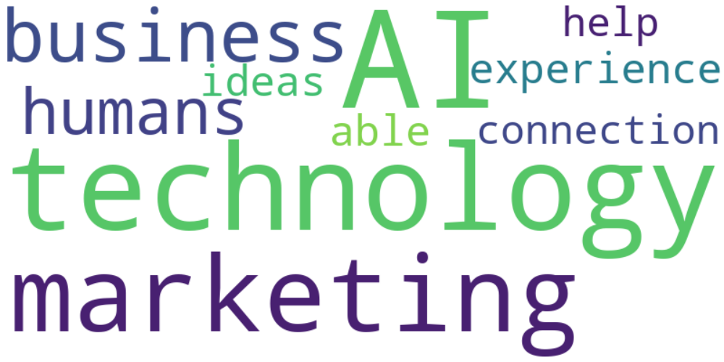

Top 10 words:

- AI: 10

- technology: 8

- marketing: 6

- like: 5

- business: 4

- humans: 3

- experience: 3

- able: 3

- ideas: 3

- connection: 3

### Wordcloud of summary

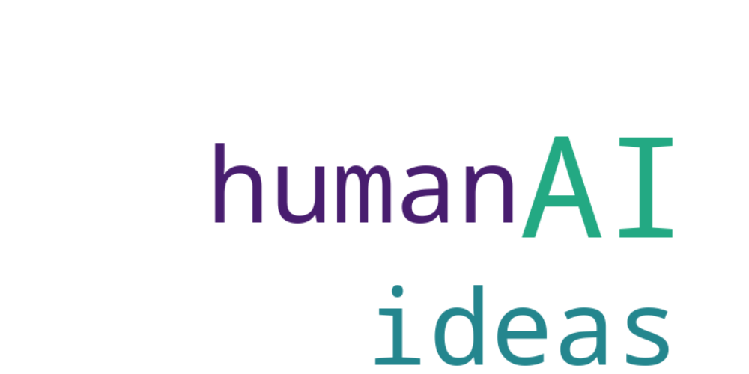

Top 10 words:

- AI: 6

- like: 4

- ideas: 3

- human: 3